**Simulation Lab- 3 Assignment (Odd Student ID)**

1. See the figure below:

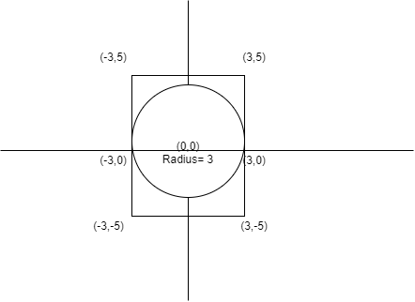

Using Monte Carlo simulation, find the value of PI and area of the circle using the given circle and square. You have to simulate the value for n=100,1000,5000 and 10000 trials. Show the scatter plot, value of PI, value of the area for each value of n. ( Just as shown in the class) .

At the end of the simulation, draw two-bar diagrams.

**First Bar Plot:**  x-axis: number of trials, y-axis: PI -value (Shown in the class)

**Second Bar Plot:** x-axis: number of trials, y-axis: Area of the circle

Output Files:

<https://drive.google.com/drive/folders/16y4BnVnyvGzWqfYs9wqilJRhDSD0mb9x?usp=sharing> (Second Bar plot has not been shown. Do it yourself)

1. Find the area under the given line below using the monte Carlo simulation.

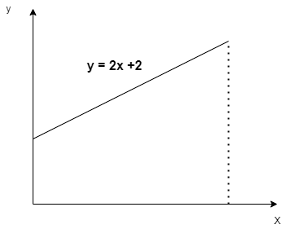

Simulate this area for n=100,1000,5000,10000 trials. For each value of n, print the area of the triangle and draw scatter plots for each case. Range of x is 0 to 3.

1. Find the area under the curve below using the monte Carlo simulation. Use the drawn rectangle.

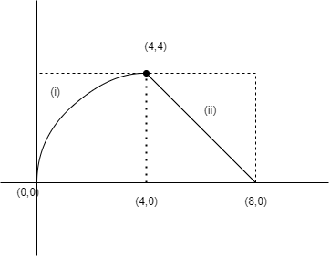

Equation of curve - (i) is : y2 = 4x

Equation of (ii) is: y = 8 - x

Simulate this area for n=100,1000,5000,10000 trials. For each value of n, print the area and draw scatter plots for each case.

**Assignment (Even Student ID)**

1. See the figure below:

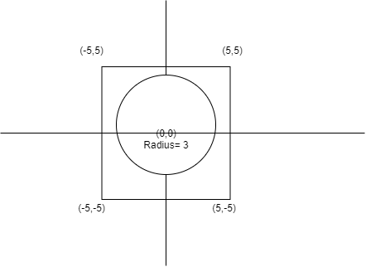

Using Monte Carlo simulation, find the value of PI and area of the circle using the given circle and square. You have to simulate the value for n=100,1000,5000 and 10000 trials. Show the scatter plot, value of PI, value of the area for each value of n. ( Just as shown in the class) .

At the end of the simulation, draw two-bar diagrams.

**First Bar Plot:**  x-axis: number of trials, y-axis: PI -value (Shown in the class)

**Second Bar Plot:** x-axis: number of trials, y-axis: Area of the circle

1. Find the area of the shaded part below using the monte Carlo simulation.

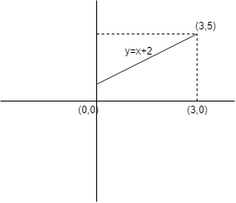

Simulate this area for n=100,1000,5000,10000 trials. For each value of n, print the area of the triangle and draw scatter plots.

1. Find the area under the curve below using the monte Carlo **Method.**  Use the drawn rectangle.



Equation of curve - (i) is : y2 = 4x

Equation of (ii) is: y = 8 - x

Simulate this area for n=100,1000,5000,10000 trials. For each value of n, print the area and draw scatter plots.